**Crop ROI Documentation**

By doing research from Telangana Agriculture department site, I have got the information about ROI of Telangana State.

* Farmers are advised avoid the application of nitrogen fertilizers. If normal conditions exist, recommended for split application of Nitrogen fertilizers (3-4 times)
* Advised to remove weed hosts from bunds.
* To improve the resistance, recommended for application of Potash in the form of MOP @ 10-15 Kgs/acre in two splits.
* To control, spray Tricyclazole + Mancozeb @ 2.5 g/lt water or Isoprothiolane @ 1.5 ml or Kasugamycin @ 2.5 ml per litre of water twice in 7-10 days interval

Table.1 Cost of cultivation of scented paddy per acre in Telangana

|  |  |  |  |  |
| --- | --- | --- | --- | --- |
| **s.no.** | **Operation Material** | **Input** | **Rate** | **Cost (Rs)** |
| **1.** | Nursery (160 Sq. m.) | | | |
| (a) Nursery preparation |  |  |  |
| (i) One discing | One tractor (35  HP) for 0.04 hours | 400/hr. | 16.00 |
| (ii) Puddling and Planking | One tractor (35  HP) for 0.12 hours | 400/hr. | 48.00 |
| (b) Layout | 0.4-man day | DC rate/man  day | 127.38 |
| (c) Sowing | 0.8-man days | DC rate /man  day | 254.77 |
| (d) Seed | 8 kg | 50/kg | 400 |
| (e) Seed treatment | 1 time |  | 50 |
| (f) Fertilizer and organic decomposed manure | 2.8 kg Urea | 5.68/kg | 15.90 |
| 2 kg DAP | 24/kg | 48.00 |
| 1.2 kg MOP | 15/kg | 18 |
| 25kg FYM | 1.5/kg | 37.50 |
|  | 0.4 kg Zinc sulphate  monohydrate | 58/kg | 23.20 |
| (g) Labour charge | 0.4-man day | DC rate/man day | 127.38 |
| (h) Weedicide | 1 time |  | 50 |
| **2.** | Field preparation | | | |
| one discing | One tractor (35  HP) for 1.6 hours | 400/hr. | 640.00 |
| Puddling |  |  | 2766.67 |
|  | Laser land leveler (3hrs/acre @ Rs.700/hour) | 1/3 (per 3  years) *1/2 (6 mths) |  | 216.67 |
| **3.** | Transplanting | In contract |  | 2466.67 |
| **4.** | Fertilizer application | 100 kg Urea | 5.68/kg | 568 |
|  |  | 50 kg DAP | 24/kg | 1200 |
|  |  | 20 kg Zinc | 58/kg | 1160 |
|  |  | sulphate |  |  |
|  |  | monohydrate | 200/kg | 200 |
|  |  | Mycorrhizal | 400 | 400 |
|  |  | biofertilizer |  |  |
|  |  | *Sesbania bispinosa* |  |  |
| **5.** | Looping of canopy | 1 man day |  | 318.46 |
| **6.** | Irrigation (comprises Labour plus canal,  electric tube wells maintenance, electricity or pumping set, diesel cost) | 10 times | 200/irrigation | 2000 |
| **7.** | Plant protection |  |  |  |
|  | White & Brown plant hopper |  |  | 500 |

|  |  |  |  |  |
| --- | --- | --- | --- | --- |
|  | Stem borers |  |  | 400 |
|  | Other spray for weedicide, insecticide,  fungicide etc. |  |  | 4000 |
| **8.** | Manual harvesting |  |  | 5000.00 |
| **9.** | Cost of transportation and marketing |  |  | 1200 |
| **10.** | Interest for 6 months (excluding rental  value of land) | 6 months | 12% per annum | 1455.16 |
|  | **Total cost of cultivation (with owned land)** |  |  | 25,707.76 |
| **11.** | Rental value of land  (This is excluded in all those cases where land is owned by the farmers) | 6 months | 28666.67/annum | 14333.33 |
|  | **Total cost of cultivation (with rented land)** |  |  | 40041.09 |
| **12.** | Production | 17q @ 2400/q |  | 40800 |
| **13** | Straw return | 12q @ 200/q |  | 2400 |
| **15.** | Gross Benefit (in both the cases) |  |  | 43200 |
| **16.** | **ROI ( with rent of land)** |  |  | 7.89 % |
| **17.** | **ROI (with owned land)** |  |  | 68.04% |
| **Benefit Rs. 3158.91; B:C= 1.079; B:C (WRoL)= 1.68; CLC= Comprising Labour Charge, ROI=Return on investment, WRoL=Without rent of land, DC= District Collector** | | | | |

**Fig.1** Cost for various operations (With rented land)

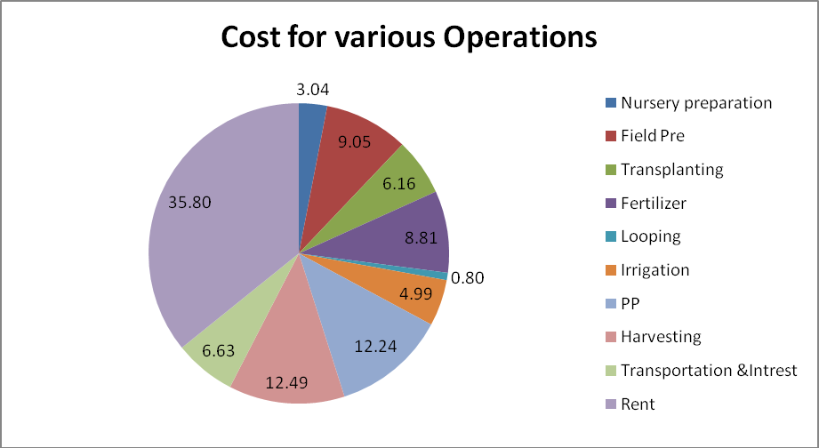

**Fig.2** Cost for various operations (Without rented land)

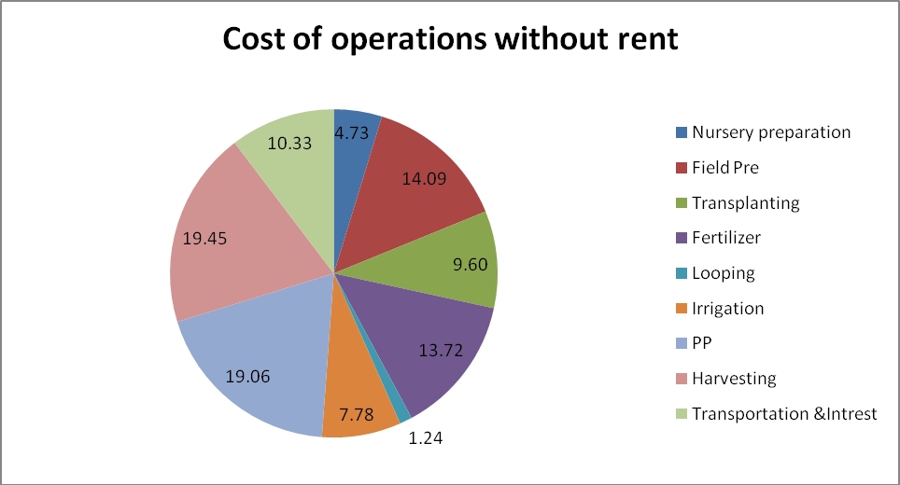

**SUGARCANE FORMING:** ROI**: -**

* The Estimation of production cost for small farmland in terms of Rs/ha is shown here. These are values that are approximate and the reality may differ from the specific values. The area of the farm and the material cost in that area contributing factors for a change in the cost if investment.

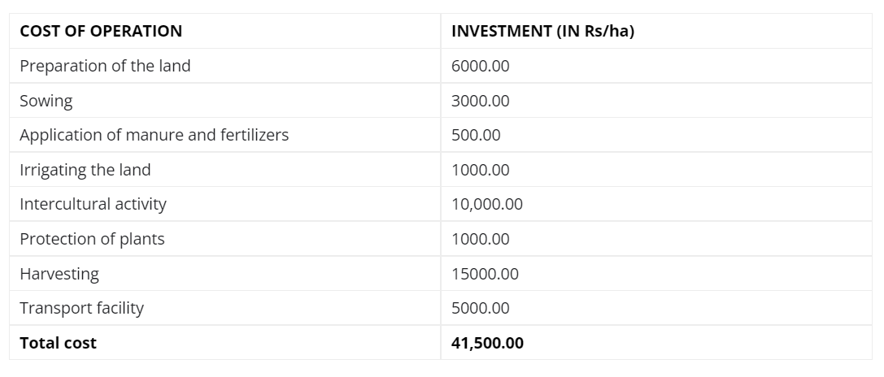

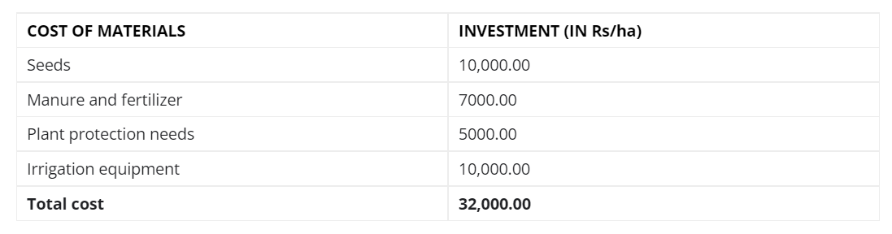

If it assumed that,

The rent of the Land: RS 30,000.00(May vary depending on the area of the form)

One small farm produce sugarcane:500 quintals.

The rate of 1 quintal of sugarcane: **Rs** 315/-

Therefore, the total value of sugarcane produced:1,57,500.00

Total investment is **Rs** 73,500.00.

The return on investment (profits is): **Rs** 84,000.00

This investment model has not included the rent of land, depreciation on implements and interest on the working capital as they would vary depending on external factors.

**Cost of cultivation for 1-acre Maize cultivation**

**Cost of seed material:**

Around 8 kilograms seeds are required for one acre maize cultivation. Cost of one kilogram maize is Rs.400. So, for total 8 kilograms it costs around Rs.3200. Seed treatment should be done if necessary.

Cost of land preparation:

Land preparation done by ploughing the soil to fine tilth. Add 8-10 tonnes of farmyard manure per acre. Furrows and ridges can be made which save irrigation water. Land preparation requires a tractor and 4 labor, totally for land preparation it costs around Rs.2600.

**Fertilizer cost for 1 acre Maize cultivation:**

Maize is highly responsive to the fertilizer application, it requires nutrients supply during all its growth, particularly it requires nitrogen throughtout growing season. It requires 48-60 kilograms nitrogen per acre it should be applied in three splits. 16-24 kilograms of phosphorus per acre and 12-16 kilograms of potash per acre. It also requires 8-10 tonnes of farmyard manure per acre. For all these it costs around Rs. 3000.

**Cost of pesticides:**

Main diseases in maize are seedling blight, soft rot, common rust and smut. Coming to pests stem borer, shoot fly, aphids and cut worms are the major pests. To manage all these pest and diseases at timely intervals it requires around Rs.1000.

**Total cost of 1-acre Maize farming in India:**

Cost of seed material – Rs. 2,500

Cost of land preparation – Rs. 1,500

Cost of sowing – Rs. 1,200

Cost of weeding – Rs. 1,000

Cost of Pesticides – Rs. 1,000

Fertilizer cost – Rs. 3,000

Cost of miscellaneous activities – Rs. 2,500

Cost of harvesting and shelling – Rs. 2,000

Cost of transportation – Rs. 500

Total cost of 1 acre Maize farming – Rs. 15,200

**Total cost incurred in 1-acre Maize cultivation:**

It costs around Rs.15,200 for cultivating maize in one acre land. However, slight changes may happened in total cost of cultivation depending upon various factors.

Total income from 1-acre Maize cultivation:

Average market price for one quintal maize is Rs.1200/qt at regional cereals market on 04-09-2019. We can get 30 quintals of yield averagely in one acre. Then totals returns will be Rs.36,000.

**Net profit from 1-acre Maize farming:**

It is the result of the difference between total returns and the total cost incurred in Maize cultivation. Then it will be like this

Rs. 36000 – Rs. 15200 = Rs. 20,800

**Cost of cultivation for 1 acre Sorghum cultivation**

**Fertilizers cost and management**

Apply 3-4 tonnes of farmyard manure during the last ploughing. It is beneficial to apply bio fertilizer to increase the yield and to reduce the cost of the chemical fertilizer. The recommended dose of NPK is 100:150:25 kg per acre under irrigated conditions during rabi. Cost incurred by the farmer in fertilization of one acre sorghum field is Rs. 2,100, in which Rs. 1,000 for farmyard manure and Rs. 1,100 for inorganic fertilizers.

**Harvesting of Sorghum crop:**

Crop is ready for harvesting after 65-75 days after sowing depending upon the variety. The crop should be harvested at proper stage to avoid grey mold damage. Harvesting operation needs around Rs. 850 for labor etc. and for threshing farmer need to incur up to Rs. 500.

**Total cost of 1-acre Sorghum farming**

Cost of seed material – Rs. 400

Cost of land preparation – Rs. 1300

Cost of sowing – Rs. 500

Cost of weeding – Rs. 400+800

Cost of Plant protection – Rs. 1750

Fertilizer cost – Rs. 2100

Cost of miscellaneous activities – Rs. 1600

Cost of harvesting and threshing – Rs. 850+ 500

Cost of transportation – Rs. 350

Cost of 1 acre Sorghum farming – Rs. 10,550

Extra 10% of total cost – Rs. 1055

Total cost of 1 acre Sorghum farming – Rs. 11,605

**The total cost incurred in 1 acre Sorghum cultivation**

On an average farmer has to spend Rs. 11,605 to cultivate sorghum in one acre. There might be little differences in the total cost of cultivation from cost mentioned above depending upon various factors.

**Total income from 1 acre Sorghum cultivation:**

The minimum support price for Sorghum for the year 2018-19 is Rs. 2550. We can get 12 quintals of yield per acre on an average basis. Then total returns will be Rs. 30,600.

**Net profit from 1 acre Sorghum farming**

Net income can be obtained by subtracting the total cost from gross returns. Then net income from 1 acre sorghum cultivation is

Rs. 30,600 – Rs. 11,605= Rs. 18,995

**REFERENCE:**

[**https://agri.telangana.gov.in/open_record_view.php?ID=959**](https://agri.telangana.gov.in/open_record_view.php?ID=959)

[**https://www.ijcmas.com/8-3-2019/Sudhanand%20Prasad%20Lal,%20et%20al.pdf**](https://www.ijcmas.com/8-3-2019/Sudhanand%20Prasad%20Lal,%20et%20al.pdf)

[**https://www.agrifarming.in/sorghum-cultivation-income-jowar-yield-project-report**](https://www.agrifarming.in/sorghum-cultivation-income-jowar-yield-project-report)

[**https://www.agrifarming.in/maize-cultivation-income-corn-cost-yield-profit**](https://www.agrifarming.in/maize-cultivation-income-corn-cost-yield-profit)

**Aradhana/Anil**